Write a query to create the Plan table with the specified columns and constraints. Refer to the below schema diagram

. 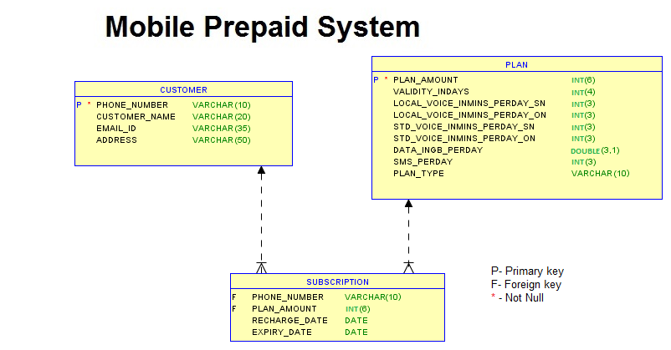

CREATE TABLE PLAN(

PLAN_AMOUNT    INT[(6)]

VALIDITY_INDAYS INT[(4)]  …………..

IS TYPE SE KRLE AAGE KA